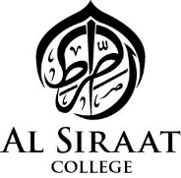
Excellence Academy at Al Siraat

Term 3 2019 Application Form:
Reading and Memory Program
13 August 2019 – 12 September 2019
Full Name of Student: _____________________________________________
Year/ Class: ____________________

PLEASE CHECK THE BOXES TO INDICATE YOUR APPROVAL
□ I would like to enrol my son/daughter in the Excellence Academy Term 3 program.
□ I understand that the program will run 4 days a week at lunch time for 25-30 minutes, and some at-home training will be required for 15-20 minutes.
□ I understand that that my child’s behaviour records will be assessed for admission into the program.
□ I have confirmed that my child is motivated to attend this program, and prepared to be regular in all sessions and training.

Student’s Signature Parent’s Signature
________________ _______________

Date: _______________________

